**Lab manual for SE**

**EXPERIMENT NO. 01**

**AIM: Software Requirement Specification**

**Theory :**

The srs should contain the following Table of Contents

**Table of Contents [ii](#_gjdgxs)**

**Revision History [ii](#_23ckvvd)**

**1. Introduction [1](#_30j0zll)**

1.1 Purpose [1](#_1fob9te)

1.2 Document Conventions [1](#_3znysh7)

1.3 Intended Audience and Reading Suggestions [1](#_2et92p0)

1.4 Product Scope [1](#_tyjcwt)

1.5 References [1](#_3dy6vkm)

**2. Overall Description [2](#_1t3h5sf)**

2.1 Product Perspective [2](#_4d34og8)

2.2 Product Functions [2](#_2s8eyo1)

2.3 User Classes and Characteristics [2](#_17dp8vu)

2.4 Operating Environment [2](#_3rdcrjn)

2.5 Design and Implementation Constraints [2](#_26in1rg)

2.6 User Documentation [2](#_lnxbz9)

2.7 Assumptions and Dependencies [3](#_35nkun2)

**3. External Interface Requirements [3](#_1ksv4uv)**

3.1 User Interfaces [3](#_44sinio)

3.2 Hardware Interfaces [3](#_2jxsxqh)

3.3 Software Interfaces [3](#_z337ya)

3.4 Communications Interfaces [3](#_3j2qqm3)

**4. System Features [4](#_1y810tw)**

4.1 System Feature 1 [4](#_4i7ojhp)

4.2 System Feature 2 (and so on) [4](#_2xcytpi)

**5. Other Nonfunctional Requirements [4](#_1ci93xb)**

5.1 Performance Requirements [4](#_3whwml4)

5.2 Safety Requirements [5](#_2bn6wsx)

5.3 Security Requirements [5](#_qsh70q)

5.4 Software Quality Attributes [5](#_3as4poj)

5.5 Business Rules [5](#_1pxezwc)

**6. Other Requirements [5](#_49x2ik5)**

**Appendix A: Glossary [5](#_2p2csry)**

**Appendix B: Analysis Models [5](#_147n2zr)**

**Appendix C: To Be Determined List [6](#_3o7alnk)**

# Introduction

## Purpose

*<Identify the product whose software requirements are specified in this document, including the revision or release number. Describe the scope of the product that is covered by this SRS, particularly if this SRS describes only part of the system or a single subsystem.>*

## Document Conventions

*<Describe any standards or typographical conventions that were followed when writing this SRS, such as fonts or highlighting that have special significance. For example, state whether priorities for higher-level requirements are assumed to be inherited by detailed requirements, or whether every requirement statement is to have its own priority.>*

## Intended Audience and Reading Suggestions

*<Describe the different types of reader that the document is intended for, such as developers, project managers, marketing staff, users, testers, and documentation writers. Describe what the rest of this SRS contains and how it is organized. Suggest a sequence for reading the document, beginning with the overview sections and proceeding through the sections that are most pertinent to each reader type.>*

## Product Scope

*<Provide a short description of the software being specified and its purpose, including relevant benefits, objectives, and goals. Relate the software to corporate goals or business strategies. If a separate vision and scope document is available, refer to it rather than duplicating its contents here.>*

## References

*<List any other documents or Web addresses to which this SRS refers. These may include user interface style guides, contracts, standards, system requirements specifications, use case documents, or a vision and scope document. Provide enough information so that the reader could access a copy of each reference, including title, author, version number, date, and source or location.>*

# Overall Description

## Product Perspective

*<Describe the context and origin of the product being specified in this SRS. For example, state whether this product is a follow-on member of a product family, a replacement for certain existing systems, or a new, self-contained product. If the SRS defines a component of a larger system, relate the requirements of the larger system to the functionality of this software and identify interfaces between the two. A simple diagram that shows the major components of the overall system, subsystem interconnections, and external interfaces can be helpful.>*

## Product Functions

*<Summarize the major functions the product must perform or must let the user perform. Details will be provided in Section 3, so only a high level summary (such as a bullet list) is needed here. Organize the functions to make them understandable to any reader of the SRS. A picture of the major groups of related requirements and how they relate, such as a top level data flow diagram or object class diagram, is often effective.>*

## User Classes and Characteristics

*<Identify the various user classes that you anticipate will use this product. User classes may be differentiated based on frequency of use, subset of product functions used, technical expertise, security or privilege levels, educational level, or experience. Describe the pertinent characteristics of each user class. Certain requirements may pertain only to certain user classes. Distinguish the most important user classes for this product from those who are less important to satisfy.>*

## Operating Environment

*<Describe the environment in which the software will operate, including the hardware platform, operating system and versions, and any other software components or applications with which it must peacefully coexist.>*

## Design and Implementation Constraints

*<Describe any items or issues that will limit the options available to the developers. These might include: corporate or regulatory policies; hardware limitations (timing requirements, memory requirements); interfaces to other applications; specific technologies, tools, and databases to be used; parallel operations; language requirements; communications protocols; security considerations; design conventions or programming standards (for example, if the customer’s organization will be responsible for maintaining the delivered software).>*

## User Documentation

*<List the user documentation components (such as user manuals, on-line help, and tutorials) that will be delivered along with the software. Identify any known user documentation delivery formats or standards.>*

## Assumptions and Dependencies

*<List any assumed factors (as opposed to known facts) that could affect the requirements stated in the SRS. These could include third-party or commercial components that you plan to use, issues around the development or operating environment, or constraints. The project could be affected if these assumptions are incorrect, are not shared, or change. Also identify any dependencies the project has on external factors, such as software components that you intend to reuse from another project, unless they are already documented elsewhere (for example, in the vision and scope document or the project plan).>*

# External Interface Requirements

## User Interfaces

*<Describe the logical characteristics of each interface between the software product and the users. This may include sample screen images, any GUI standards or product family style guides that are to be followed, screen layout constraints, standard buttons and functions (e.g., help) that will appear on every screen, keyboard shortcuts, error message display standards, and so on. Define the software components for which a user interface is needed. Details of the user interface design should be documented in a separate user interface specification.>*

## Hardware Interfaces

*<Describe the logical and physical characteristics of each interface between the software product and the hardware components of the system. This may include the supported device types, the nature of the data and control interactions between the software and the hardware, and communication protocols to be used.>*

## Software Interfaces

*<Describe the connections between this product and other specific software components (name and version), including databases, operating systems, tools, libraries, and integrated commercial components. Identify the data items or messages coming into the system and going out and describe the purpose of each. Describe the services needed and the nature of communications. Refer to documents that describe detailed application programming interface protocols. Identify data that will be shared across software components. If the data sharing mechanism must be implemented in a specific way (for example, use of a global data area in a multitasking operating system), specify this as an implementation constraint.>*

## Communications Interfaces

*<Describe the requirements associated with any communications functions required by this product, including e-mail, web browser, network server communications protocols, electronic forms, and so on. Define any pertinent message formatting. Identify any communication standards that will be used, such as FTP or HTTP. Specify any communication security or encryption issues, data transfer rates, and synchronization mechanisms.>*

# System Features

*<This template illustrates organizing the functional requirements for the product by system features, the major services provided by the product. You may prefer to organize this section by use case, mode of operation, user class, object class, functional hierarchy, or combinations of these, whatever makes the most logical sense for your product.>*

## System Feature 1

*<Don’t really say “System Feature 1.” State the feature name in just a few words.>*

4.1.1 Description and Priority

*<Provide a short description of the feature and indicate whether it is of High, Medium, or Low priority. You could also include specific priority component ratings, such as benefit, penalty, cost, and risk (each rated on a relative scale from a low of 1 to a high of 9).>*

4.1.2 Stimulus/Response Sequences

*<List the sequences of user actions and system responses that stimulate the behavior defined for this feature. These will correspond to the dialog elements associated with use cases.>*

4.1.3 Functional Requirements

*<Itemize the detailed functional requirements associated with this feature. These are the software capabilities that must be present in order for the user to carry out the services provided by the feature, or to execute the use case. Include how the product should respond to anticipated error conditions or invalid inputs. Requirements should be concise, complete, unambiguous, verifiable, and necessary. Use “TBD” as a placeholder to indicate when necessary information is not yet available.>*

*<Each requirement should be uniquely identified with a sequence number or a meaningful tag of some kind.>*

REQ-1:

REQ-2:

## System Feature 2 (and so on)

# Other Nonfunctional Requirements

## Performance Requirements

*<If there are performance requirements for the product under various circumstances, state them here and explain their rationale, to help the developers understand the intent and make suitable design choices. Specify the timing relationships for real time systems. Make such requirements as specific as possible. You may need to state performance requirements for individual functional requirements or features.>*

## Safety Requirements

*<Specify those requirements that are concerned with possible loss, damage, or harm that could result from the use of the product. Define any safeguards or actions that must be taken, as well as actions that must be prevented. Refer to any external policies or regulations that state safety issues that affect the product’s design or use. Define any safety certifications that must be satisfied.>*

## Security Requirements

*<Specify any requirements regarding security or privacy issues surrounding use of the product or protection of the data used or created by the product. Define any user identity authentication requirements. Refer to any external policies or regulations containing security issues that affect the product. Define any security or privacy certifications that must be satisfied.>*

## Software Quality Attributes

*<Specify any additional quality characteristics for the product that will be important to either the customers or the developers. Some to consider are: adaptability, availability, correctness, flexibility, interoperability, maintainability, portability, reliability, reusability, robustness, testability, and usability. Write these to be specific, quantitative, and verifiable when possible. At the least, clarify the relative preferences for various attributes, such as ease of use over ease of learning.>*

## Business Rules

*<List any operating principles about the product, such as which individuals or roles can perform which functions under specific circumstances. These are not functional requirements in themselves, but they may imply certain functional requirements to enforce the rules.>*

# Other Requirements

*<Define any other requirements not covered elsewhere in the SRS. This might include database requirements, internationalization requirements, legal requirements, reuse objectives for the project, and so on. Add any new sections that are pertinent to the project.>*

**Appendix A: Glossary**

*<Define all the terms necessary to properly interpret the SRS, including acronyms and abbreviations. You may wish to build a separate glossary that spans multiple projects or the entire organization, and just include terms specific to a single project in each SRS.>*

**Appendix B: Analysis Models**

*<Optionally, include any pertinent analysis models, such as data flow diagrams, class diagrams, state-transition diagrams, or entity-relationship diagrams*.>

**Appendix C: To Be Determined List**

*<Collect a numbered list of the TBD (to be determined) references that remain in the SRS so they can be tracked to closure.>*

**Reference:**

1. www.csc.villanova.edu/~tway/courses/csc4181/.../**srs**\_**template**-1.

**Experiment 2: Draw DFD (upto 2 levels)**

**Learning Objective:** Students will able to identify the data flows, processes, source and destination for their mini-project and analyze and design the DFD up to 2 levels

**Tools:**  Draw.io, StarUML

**Theory:**

A Data Flow Diagram (DFD) is a traditional visual representation of the information flows within a system. A neat and clear DFD can depict the right amount of the system requirement graphically. It can be manual, automated, or a combination of both.

The objective of a DFD is to show the scope and boundaries of a system as a whole. It may be used as a communication tool between a system analyst and any person who plays a part in the order that acts as a starting point for redesigning a system. The DFD is also called as a data flow graph or bubble chart.

**The following observations about DFDs are essential:**

1. All names should be unique. This makes it easier to refer to elements in the DFD.
2. Remember that DFD is not a flow chart. Arrows is a flow chart that represents the order of events; arrows in DFD represents flowing data. A DFD does not involve any order of events.
3. Suppress logical decisions. If we ever have the urge to draw a diamond-shaped box in a DFD, suppress that urge! A diamond-shaped box is used in flow charts to represents decision points with multiple exists paths of which the only one is taken. This implies an ordering of events, which makes no sense in a DFD.
4. Do not become bogged down with details. Defer error conditions and error handling until the end of the analysis.

Standard symbols for DFDs are derived from the electric circuit diagram analysis and are shown in fig:

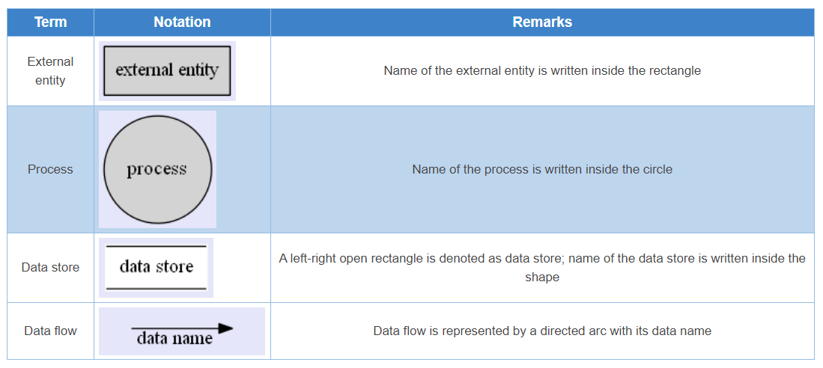

* **Process:** Processes are represented by circle. The name of the process is written into the circle. The name of the process is usually given in such a way that represents the functionality of the process. More detailed functionalities can be shown in the next Level if it is required. Usually it is better to keep the number of processes less than 7. If we see that the number of processes becomes more than 7 then we should combine some the processes to a single one to reduce the number of processes and further decompose it to the next level.
* **External entity**: External entities only appear in context diagram. External entities are represented by a rectangle and the name of the external entity is written into the shape. These send data to be processed and again receive the processed data.
* **Data store:** Data stores are represented by a left-right open rectangle. Name of the data store is written in between two horizontal lines of the open rectangle. Data stores are used as repositories from which data can be flown in or flown out to or from a process.
* **Data flow:** Data flows are shown as a directed edge between two components of a Data Flow Diagram. Data can flow from external entity to process, data store to process, in between two processes and vice-versa.

**Levels in Data Flow Diagrams (DFD)**

The DFD may be used to perform a system or software at any level of abstraction. Infact, DFDs may be partitioned into levels that represent increasing information flow and functional detail. Levels in DFD are numbered 0, 1, 2 or beyond. Here, we will see primarily three levels in the data flow diagram, which are: 0-level DFD, 1-level DFD, and 2-level DFD.

**0-level DFD**

It is also known as fundamental system model, or context diagram represents the entire software requirement as a single bubble with input and output data denoted by incoming and outgoing arrows. Then the system is decomposed and described as a DFD with multiple bubbles. Parts of the system represented by each of these bubbles are then decomposed and documented as more and more detailed DFDs. This process may be repeated at as many levels as necessary until the program at hand is well understood. It is essential to preserve the number of inputs and outputs between levels, this concept is called leveling by DeMacro. Thus, if bubble "A" has two inputs x1 and x2 and one output y, then the expanded DFD, that represents "A" should have exactly two external inputs and one external output as shown in fig:

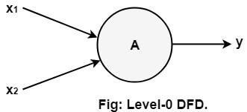

**1-level DFD**

In 1-level DFD, a context diagram is decomposed into multiple bubbles/processes. In this level, we highlight the main objectives of the system and breakdown the high-level process of 0-level DFD into sub-processes.

**2-Level DFD**

2-level DFD goes one process deeper into parts of 1-level DFD. It can be used to project or record the specific/necessary detail about the system's functioning.

**Steps in developing DFDs**

1. List business activities to identify processes, external entities, data flows, and data stores
2. Create a context diagram
3. Create the next level diagram
4. Create child diagrams.

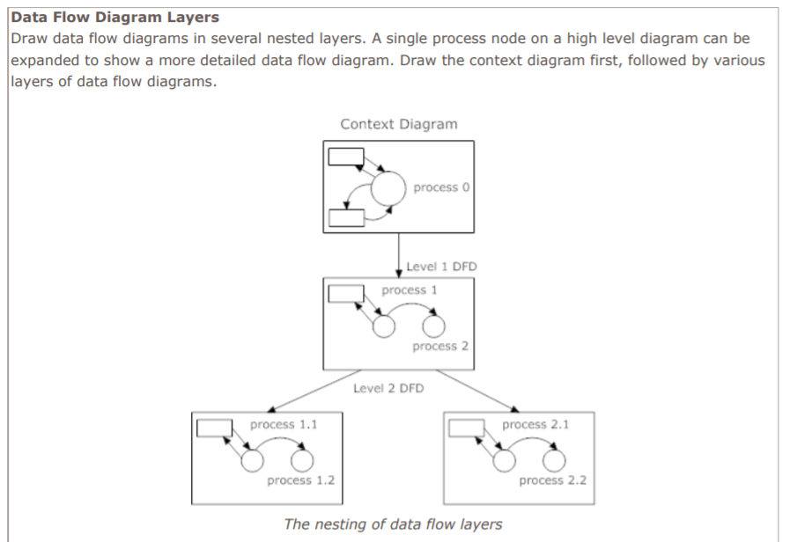

**Result and Discussion:**

Draw context diagram, Level-1 DFD and Level-2 DFD for mini project.

(*ADD HERE*)

**Learning Outcomes:** Students should have the ability to

LO1: Identify the data-flows, processes, source and destination for the project.

LO2: Analyze and design the DFD up to 2 levels

**Outcomes:** Upon completion of the course students will be able to prepare draw DFD (up to 2 levels)

**Conclusion:**  *WRITE HERE*

**Viva Questions:**

1. What is a context diagram?  
2. Can the data flow directly between two data stores?  
3. Why data dictionaries are maintained?  
4.  What are the rules to create DFDs?

**For Faculty Use**https://docs.google.com/drawings/u/0/d/sMPeBm1ly10pGVKD5V9izNg/image?w=1&h=1&rev=1&ac=1&parent=1HkCPOwvDZE1mKjYdnZTzU5QwTfuFOVtgz2SaqQNfS-k

| **Correction Parameters** | **Formative Assessment [40%]** | **Timely completion of Practical [ 40%]** | **Attendance / Learning Attitude [20%]** |  |
| --- | --- | --- | --- | --- |
| **Marks Obtained** |  |  |  |

**Experiment 03- Implement UML Use-case**

**Learning Objective:** To implement UML use-case for the project.

**Tools:**  MS Word, draw.io

**Theory:**

**Use case diagrams**

**Use case diagrams belong to the category of behavioral diagram** of UML diagrams. They present a graphical overview of the functionality provided by the system. It consists of a set of actions (referred to as use cases) that the concerned system can perform one or more actors, and dependencies among them.

**Actor**

An actor can be defined as an object or set of objects, external to the system, which interacts with the system to get some meaningful work done. Actors could be human, devices, or even other systems.

For example, consider the case where a customer *withdraws cash* from an ATM. Here, customer is a human actor.

Actors can be classified as below:

* **Primary actor**: They are principal users of the system, who fulfill their goal by availing some service from the system. For example, a customer uses an ATM to withdraw cash when he needs it. A customer is the primary actor here.
* **Supporting actor**: They render some kind of service to the system. "Bank representatives", who replenishes the stock of cash, is such an example. It may be noted that replenishing stock of cash in an ATM is not the prime functionality of an ATM.

In a use case diagram primary actors are usually drawn on the top left side of the diagram.

**Use Case**

A use case is simply a functionality provided by a system.

Continuing with the example of the ATM, *withdraw cash* is a functionality that the ATM provides. Therefore, this is a use case. Other possible use cases include, *check balance*, *change PIN*, and so on.

Use cases include both successful and unsuccessful scenarios of user interactions with the system. For example, authentication of a customer by the ATM would fail if he enters wrong PIN. In such case, an error message is displayed on the screen of the ATM.

**Subject**

Subject is simply the system under consideration.

**Graphical Representation**

An actor is represented by a stick figure and name of the actor is written below it. A use case is depicted by an ellipse and name of the use case is written inside it. The subject is shown by drawing a rectangle. Label for the system could be put inside it. Use cases are drawn inside the rectangle, and actors are drawn outside the rectangle, as shown in figure - 01.

Figure - 01: A use case diagram for a book store

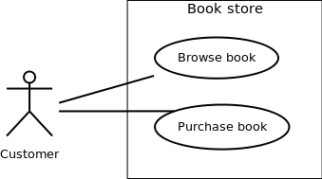

**Association between Actors and Use Cases**

A use case is triggered by an actor. Actors and use cases are connected through binary associations indicating that the two communicates through message passing.

An actor must be associated with at least one use case. Similarly, a given use case must be associated with at least one actor. Association among the actors is usually not shown. However, one can depict the class hierarchy among actors.

**Use Case Relationships**

Three types of relationships exist among use cases:

* Include relationship
* Extend relationship
* Use case generalization

**Include Relationship**

Include relationships are used to depict common behavior that are shared by multiple use cases. This could be considered analogous to writing functions in a program in order to avoid repetition of writing the same code. Such a function would be called from different points within the program.

**Example**

For example, consider an email application. A user can send a new mail, reply to an email he has received, or forward an email. However, in each of these three cases, the user must be logged in to perform those actions. Thus, we could have a *login* use case, which is included by *compose mail*, *reply*, and *forward email* use cases. The relationship is shown in figure - 02.

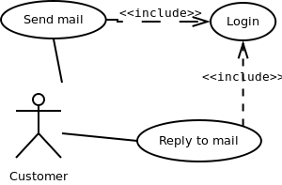

Figure - 02: Include relationship between use cases

**Notation**

Include relationship is depicted by a dashed arrow with a «include» stereotype from the including use case to the included use case.

**Extend Relationship**

Use case extensions are used to depict any variation to an existing use case. They are used to specify the changes required when any assumption made by the existing use case becomes false.

**Example**

Let's consider an online bookstore. The system allows an authenticated user to buy selected book(s). While the order is being placed, the system also allows specifying any special shipping instructions, for example, call the customer before delivery. This *Shipping Instructions* step is optional, and not a part of the main *Place Order* use case. Figure - 03 depicts such relationship.

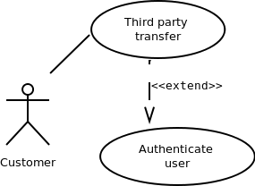

Figure - 03: Extend relationship between use cases

**Notation**

Extend relationship is depicted by a dashed arrow with a «extend» stereotype from the extending use case to the extended use case.

**Generalization Relationship**

Generalization relationship is used to represent the inheritance between use cases. A derived use case specializes some functionality it has already inherited from the base use case.

**Example**

To illustrate this, consider a graphical application that allows users to draw polygons. We could have a use case *draw polygon*. Now, rectangle is a particular instance of polygon having four sides at right angles to each other. So, the use case *draw rectangle* inherits the properties of the use case *draw polygon* and overrides its drawing method. This is an example of generalization relationship. Similarly, a generalization relationship exists between *draw rectangle* and *draw square* use cases. The relationship has been illustrated in figure - 04.

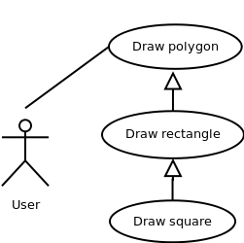

Figure - 04: Generalization relationship among use cases

**Notation**

Generalization relationship is depicted by a solid arrow from the specialized (derived) use case to the more generalized (base) use case.

Identifying Actors

Given a problem statement, the actors could be identified by asking the following questions:

* Who gets most of the benefits from the system? (The answer would lead to the identification of the primary actor)
* Who keeps the system working? (This will help to identify a list of potential users)
* What other software / hardware does the system interact with?
* Any interface (interaction) between the concerned system and any other system?

**Identifying Use cases**

Once the primary and secondary actors have been identified, we have to find out their goals i.e. what the functionality they can obtain from the system is. Any use case name should start with a verb like, "Check balance".

Guidelines for drawing Use Case diagrams

Following general guidelines could be kept in mind while trying to draw a use case diagram:

* Determine the system boundary
* Ensure that individual actors have well-defined purpose
* Use cases identified should let some meaningful work done by the actors
* Associate the actors and use cases -- there shouldn't be any actor or use case floating without any connection
* Use include relationship to encapsulate common behavior among use cases, if any.

**Result and Discussion:**

Q.1) What is a use-case diagram? Draw at least two use-cases for your projects.

(*Draw here*)

Q.2) What are the components in a use-case diagram?

(*Write here*)

**Learning Outcomes:** The student should have the ability to:

LO 1: Identify the importance of use-case diagrams.

LO 2: Draw use-case diagrams for a given scenario.

**Course Outcomes:** Upon completion of the course students will be able to understand and demonstrate use-case diagrams.

**Conclusion:** (*write here*)

**Viva Questions:**

1. What is use-case diagrams used for?

2. What is extends and include? Differentiate between the two.

3. What is a generalization relationship in a use-case?

4. “Use case diagrams belong to the category of behavioral diagram”. What does the statement mean?

For Faculty Use:

| **Correction Parameters** | **Formative Assessment [40%]** | **Timely completion of Practical [ 40%]** | **Attendance / Learning Attitude [20%]** |  | | |
| --- | --- | --- | --- | --- | --- | --- |
| **Marks Obtained** |  |  |  |
|  |  |  |  |  |  |  |

**Experiment 04- Implement Class Diagram**

**Learning Objective:** To implement UML class diagram for the project.

**Tools:** MS Word, draw.io or any other UML tool.

**Theory:**

**Class Diagrams:**

Classes are the structural units in object oriented system design approach, so it is essential to know all the relationships that exist between the classes, in a system. All objects in a system are also interacting to each other by means of passing messages from one object to another.

**Elements in class diagram**

Class diagram contains the system classes with its data members, operations and relationships between classes.

**Class**

A set of objects containing similar data members and member functions is described by a class. In UML syntax, class is identified by solid outline rectangle with three compartments which contain

● **Class name**

A class is uniquely identified in a system by its name. It lies in the first compartment in class rectangle.

● **Attributes**

Property shared by all instances of a class. It lies in the second compartment in class rectangle. ● **Operations**

An execution of an action can be performed for any object of a class. It lies in the last compartment in class rectangle.

**Example**

To build a structural model for an Educational Organization, ‘Course’ can be treated as a class which contains attributes ‘courseName’ & ‘courseID’ with the operations ‘addCourse()’ & ‘removeCourse()’ allowed to be performed for any object to that class.

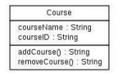

● **Generalization/Specialization**

It describes how one class is derived from another class. Derived class inherits the properties of its parent class.

**Example**

**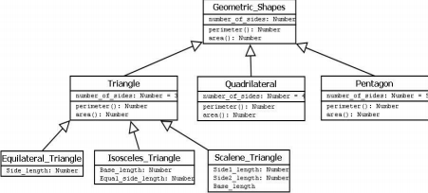**Figure-02:

Geometric\_Shapes is the class that describes how many sides a particular shape has. Triangle, Quadrilateral and Pentagon are the classes that inherit the property of the Geometric\_Shapes class. So the relations among these classes are generalization. Now Equilateral\_Triangle, Isosceles\_Triangle and Scalene\_Triangle, all these three classes inherit the properties of Triangle class as each one of them has three sides. So, these are specialization of Triangle class.

**Relationships**

Existing relationships in a system describe legitimate connections between the classes in that system. ● **Association**

It is an instance level relationship that allows exchanging messages among the objects of both ends of association. A simple straight line connecting two class boxes represent an association. We can give a



name to association and also at the both end we may indicate role names and multiplicity of the adjacent classes. Association may be uni-directional.

**Example**

In structure model for a system of an organization an employee (instance of ‘Employee’ class) is always assigned to a particular department (instance of ‘Department’ class) and the association can be shown by a line connecting the respective classes.

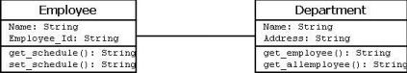Figure-03:

● **Aggregation**

It is a special form of association which describes a part-whole relationship between a pair of classes. It means, in a relationship, when a class holds some instances of related class, then that relationship can be designed as an aggregation.

**Example**

For a supermarket in a city, each branch runs some of the departments they have. So, the relation among the classes ‘Branch’ and ‘Department’ can be designed as aggregation. In UML, it can be shown as in the fig. below.

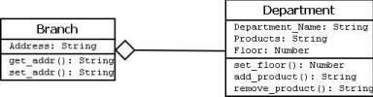Figure-04:

● Composition

It is a strong from of aggregation which describes that whole is completely owns its part. Life cycle of the part depends on the whole.

**Example**

****

Let consider a shopping mall has several branches in different locations in a city. The existence of branches completely depends on the shopping mall as if it is not exist any branch of it will no longer exists in the city. This relation can be described as composition and can be shown as below

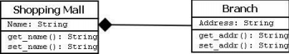

Figure-05:

● **Multiplicity**

It describes how many numbers of instances of one class is related to the number of instances of another class in an association.

**Notation for different types of multiplicity:**

**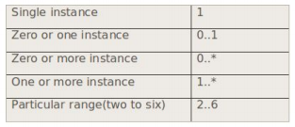**

Figure-06:

**Example**

One vehicle may have two or more wheels

https://lh3.googleusercontent.com/S-_aqI1nyvhHTV_lutJz0DXPawoIQTvBdNp_zad-4dUlUHqF40Oe4ABKWxcIfcKc6m-vHBchHUMACpqL0_lGd3eH99qjOuWxgF3uWxv4jL0baEAxXhfIfeZpERzgGJa66EecWNw

Figure-07:

**Procedure:**

****

When required to describe the static view of a system or its functionalities, we would be required to draw a class diagram. Here are the steps you need to follow to create a class diagram.

*Step 1: Identify the class names*

The first step is to identify the primary objects of the system.

*Step 2: Distinguish relationships*

Next step is to determine how each of the classes or objects are related to one another. Look out for commonalities and abstractions among them; this will help you when grouping them when drawing the class diagram.

*Step 3: Create the Structure*

First, add the class names and link them with the appropriate connectors. You can add attributes and functions/ methods/ operations later.

**Result and Discussion:**

Q.1) What is a Class diagram?

Q.2) Draw the class diagram for your project.

**Learning Outcomes:** The student should have the ability to:

LO 1: Identify the importance of class diagrams.

LO 2: Draw class diagrams for a given scenario.

**Course Outcomes:** Upon completion of the course students will be able to understand and demonstrate class diagrams.

**Conclusion:**

**Viva Questions:**

1. What is class diagram used for?

2. Enumerate on the type of relationships between classes.

3. What do you understand by multiplicity factor in class diagrams?

**For Faculty Use**https://docs.google.com/drawings/u/0/d/sMPeBm1ly10pGVKD5V9izNg/image?w=1&h=1&rev=1&ac=1&parent=1HkCPOwvDZE1mKjYdnZTzU5QwTfuFOVtgz2SaqQNfS-k

| **Correction Parameters** | **Formative Assessment [40%]** | **Timely completion of Practical [ 40%]** | **Attendance / Learning Attitude [20%]** |  |
| --- | --- | --- | --- | --- |
| **Marks Obtained** |  |  |  |

**Experiment 05- Implement State/Activity diagrams**

**Learning Objective:** To implement dynamic view of a system using Activity/State diagrams.

**Tools:**  MS Word, draw.io

**Theory:**

Capturing the dynamic view of a system is very important for a developer to develop the logic for a system. State chart diagrams and activity diagrams are two popular UML diagram to visualize the dynamic behavior of an information system.

In this experiment, we will learn about the different components of activity diagram and state chart diagram and how these can be used to represent the dynamic nature of an information system.

**State-chart Diagrams**

In case of Object Oriented Analysis and Design, a system is often abstracted by one or more classes with some well defined behavior and states. A *state chart diagram* is a pictorial representation of such a system, with all its states, and different events that lead transition from one state to another.

To illustrate this, consider a computer. Some possible states that it could have are: running, shutdown, hibernate. A transition from running state to shutdown state occur when user presses the "Power off" switch, or clicks on the "Shut down" button as displayed by the OS. Here, clicking on the shutdown button, or pressing the power off switch act as external events causing the transition.

State-chart diagrams are normally drawn to model the behavior of a complex system. For simple systems this is optional.

Building Blocks of a State-chart Diagram

**State**

A state is any "distinct" stage that an object (system) passes through in it's lifetime. An object remains in a given state for finite time until "something" happens, which makes it to move to another state.  All such states can be broadly categorized into following three types:

* Initial: The state in which an object remain when created
* Final: The state from which an object do not move to any other state [optional]
* Intermediate: Any state, which is neither initial, nor final

As shown in figure-01, an initial state is represented by a circle filled with black. An intermediate state is depicted by a rectangle with rounded corners. A final state is represented by a unfilled circle with an inner black-filled circle.

C:\Users\kalpa\Desktop\states_symbol.png

Figure-01: Representation of initial, intermediate, and final states of a state chart diagram

Intermediate states usually have two compartments, separated by a horizontal line, called the name compartment and internal transitions compartment. They are described below:

* Name compartment: Contains the name of the state, which is a short, simple, descriptive string
* Internal transitions compartment: Contains a list of internal activities performed as long as the system is in this state

The internal activities are indicated using the following syntax: action-label / action-expression. Action labels could be any condition indicator. There are, however, four special action labels:

* Entry: Indicates activity performed when the system enter this state
* Exit: Indicates activity performed when the system exits this state
* Do: indicate any activity that is performed while the system remain in this state or until the action expression results in a completed computation
* Include: Indicates invocation of a sub-machine

Any other action label identifies the event (internal transition) as a result of which the corresponding action is triggered. Internal transition is almost similar to self transition, except that the former doesn't result in execution of entry and exit actions. That is, system doesn't exit or re-enter that state. Figure-02 shows the syntax for representing a typical (intermediate) state

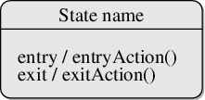

Figure-02: A typical state in a state chart diagram

States could again be either simple or composite. Here, however, we will deal only with simple states.

**Transition**

Transition is movement from one state to another state in response to an external stimulus (or any internal event). A transition is represented by a solid arrow from the current state to the next state. It is labeled by: event [guard-condition]/[action-expression], where

* Event is the what is causing the concerned transition (mandatory) -- Written in past tense
* Guard-condition is (are) precondition(s), which must be true for the transition to happen
* Action-expression indicate action(s) to be performed as a result of the transition

It may be noted that if a transition is triggered with one or more guard-condition(s), which evaluate to false, the system will continue to stay in the present state. Also, not all transitions do result in a state change. For example, if a queue is full, any further attempt to append will fail until the delete method is invoked at least once. Thus, state of the queue doesn't change in this duration.

**Action**

An action represents behavior of the system. While the system is performing any action for the current event, it doesn't accept or process any new event. The order, in which different actions are executed, is given below:

1. Exit actions of the present state
2. Actions specified for the transition
3. Entry actions of the next state

**Activity Diagrams**

Activity diagrams fall under the category of behavioral diagrams in Unified Modeling Language. It is a high level diagram used to visually represent the flow of control in a system. It has similarities with traditional flow charts. However, it is more powerful than a simple flow chart since it can represent various other concepts like concurrent activities, their joining, and so on.

Activity diagrams, however, cannot depict the message passing among related objects. As such, it can't be directly translated into code. These kinds of diagrams are suitable for confirming the logic to be implemented with the business users. These diagrams are typically used when the business logic is complex. In simple scenarios it can be avoided entirely.

**Components of an Activity Diagram**

Below we describe the building blocks of an activity diagram.

**Activity**

An activity denotes a particular action taken in the logical flow of control. This could simply be invocation of a mathematical function, alter an object's properties and so on. An activity is represented with a rounded rectangle, as shown in table-01. A label inside the rectangle identifies the corresponding activity.

There are two special types of activity nodes: initial and final. They are represented with a filled circle, and a filled in circle with a border respectively (table-01). Initial node represents the starting point of a flow in an activity diagram. There could be multiple initial nodes, which mean that invoking that particular activity diagram would initiate multiple flows.

A final node represents the end point of all activities. Like an initial node, there could be multiple final nodes. Any transition reaching a final node would stop all activities.

**Flow**

A flow (also termed as edge or transition) is represented with a directed arrow. This is used to depict transfer of control from one activity to another, or to other types of components, as we will see below. A flow is often accompanied with a label, called the guard condition, indicating the necessary condition for the transition to happen. The syntax to depict it is [guard condition].

**Decision**

A decision node, represented with a diamond, is a point where a single flow enters and two or more flows leave. The control flow can follow only one of the outgoing paths. The outgoing edges often have guard conditions indicating true-false or if-then-else conditions. However, they can be omitted in obvious cases. The input edge could also have guard conditions. Alternately, a note can be attached to the decision node indicating the condition to be tested.

**Merge**

This is represented with a diamond shape, with two or more flows entering, and a single flow leaving out. A merge node represents the point where at least a single control should reach before further processing could continue.

**Fork**

Fork is a point where parallel activities begin. For example, when a student has been registered with a college, he can in parallel apply for student ID card and library card. A fork is graphically depicted with a black bar, with a single flow entering and multiple flows leaving out.

**Join**

A join is depicted with a black bar, with multiple input flows, but a single output flow. Physically it represents the synchronization of all concurrent activities. Unlike a merge, in case of a join all of the incoming controls **must be completed** before any further progress could be made. For example, a sales order is closed only when the customer has received the product, **and** the sales company has received its payment.

**Note**

UML allows attaching a note to different components of a diagram to present some textual information. The information could simply be a comment or may be some constraint. A note can be attached to a decision point, for example, to indicate the branching criteria.

**Partition**

Different components of an activity diagram can be logically grouped into different areas, called partitions or swim lanes. They often correspond to different units of an organization or different actors. The drawing area can be partitioned into multiple compartments using vertical (or horizontal) parallel lines. Partitions in an activity diagram are not mandatory. The following table shows commonly used components with a typical activity diagram.

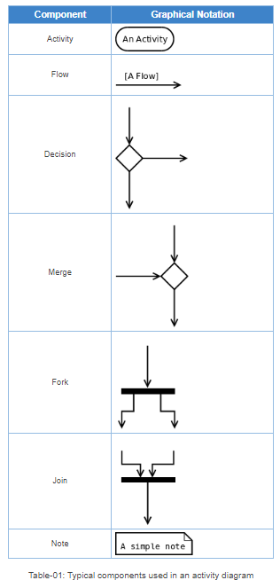

**A Simple Example**

Figure-04 shows a simple activity diagram with two activities. The figure depicts two stages of a form submission. At first a form is filled up with relevant and correct information. Once it is verified that there is no error in the form, it is then submitted. The two other symbols shown in the figure are the initial node (dark filled circle), and final node (outer hollow circle with inner filled circle). It may be noted that there could be zero or more final node(s) in an activity diagram.

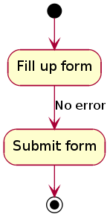

Figure-04: A simple activity diagram.

**Procedure:**

Guidelines for drawing State chart Diagrams

Following steps could be followed, to draw a state chart diagram:

* For the system to developed, identify the distinct states that it passes through
* Identify the events (and any precondition) that cause the state transitions. Often these would be the methods of a class as identified in a class diagram.
* Identify what activities are performed while the system remains in a given state

**Result and Discussion:**

Q.1) what is a dynamic view of a system? Draw at least one state diagram and one activity diagram for your mini project.

**Learning Outcomes:** The student should have the ability to:

LO 1: Identify the importance of state diagram.

LO 2: Draw activity diagrams for a given scenario.

**Course Outcomes:** Upon completion of the course students will be able to understand and demonstrate state and activity diagrams.

**Conclusion:** Thus, students have understood and successfully drawn state and activity diagrams.

**Viva Questions:**

1. What is a state diagram used for?

2. Enumerate the steps to draw an activity diagram.

For Faculty Use:

| **Correction Parameters** | **Formative Assessment [40%]** | **Timely completion of Practical [ 40%]** | **Attendance / Learning Attitude [20%]** |  | | |
| --- | --- | --- | --- | --- | --- | --- |
| **Marks Obtained** |  |  |  |
|  |  |  |  |  |  |  |

**Experiment 6: Sketch Sequence diagram for the project**

**Learning Objective:** Students will able to draw Sequence diagram for the project

**Tools:**  Dia, StarUML

**Theory:**

A sequence diagram shows, as parallel vertical lines (*lifelines*), different processes or objects that live simultaneously, and, as horizontal arrows, the messages exchanged between them, in the order in which they occur. This allows the specification of simple runtime scenarios in a graphical manner.

**Sequence Diagram representation**

## Call Message: A message defines a particular communication between Lifelines of an Interaction.

## Destroy Message: Destroy message is a kind of message that represents the request of destroying the lifecycle of target lifeline.

## Lifeline: A lifeline represents an individual participant in the Interaction.

## Recursive Message: Recursive message is a kind of message that represents the invocation of message of the same lifeline. Its target points to an activation on top of the activation where the message was invoked from.

**Sequence Diagram: Example for ATM System startup**

## https://lh3.googleusercontent.com/19ZK27vwFDsS3w2o8oao0G1nu5EybFGc8g_YSR7-shmgtyEsbFE4qJusTzGgvPP24a96KxJ5KZq_fsqxqf7tC8epxPhUIhZhqGSAWWYjg3DzqDUqPDAgx6cxmpsHdqlDggG4F8yEYZCLeCq-

It is clear that sequence charts have a number of very powerful advantages. They clearly depict the sequence of events, show when objects are created and destroyed, are excellent at depicting concurrent operations, and are invaluable for hunting down race conditions. However, with all their advantages, they are not perfect tools. They take up a lot of space, and do not present the interrelationships between the collaborating objects very well.

**Learning Outcomes:** Students should have the ability to

LO1: Identify the classes and objects.

LO2: Identify the interactions between the objects

LO3: Develop a sequence diagram for different scenarios

**Outcomes:** Upon completion of the course students will be able to draw the sequence diagram for the project.

**Conclusion:**

\_\_\_\_\_\_\_\_\_\_\_\_\_\_\_\_\_\_\_\_\_\_\_\_\_\_\_\_\_\_\_\_\_\_\_\_\_\_\_\_\_\_\_\_\_\_\_\_\_\_\_\_\_\_\_\_\_\_\_\_\_\_\_\_\_\_\_\_\_\_\_\_\_\_\_\_\_\_\_\_\_\_\_\_\_\_\_\_\_\_\_\_\_\_\_\_\_\_\_\_\_\_\_\_\_\_\_\_\_\_\_\_\_\_\_\_\_\_\_\_\_\_\_\_\_\_\_\_\_\_\_\_\_\_\_\_\_\_\_\_\_\_\_\_\_\_\_\_\_\_\_\_\_\_\_\_\_\_\_\_\_\_

**Viva Questions:**

1. **What is a sequence diagram?**
2. **What are advantages of sequence diagram?**
3. **What are entities in sequence diagram?**
4. **Explain its relation with the class diagram?**

For Faculty Usehttps://docs.google.com/drawings/u/0/d/sekwtG188UjWa3SoGuP7P4w/image?w=814&h=3&rev=1&ac=1&parent=1ok0uxvmAUDJURzD1ZTcvRNp-oe_CBKJ9sZtSYbqh9Dg

| **Correction Parameters** | **Formative Assessment [40%]** | **Timely completion of Practical [ 40%]** | **Attendance / Learning Attitude [20%]** |  |
| --- | --- | --- | --- | --- |
| **Marks Obtained** |  |  |  |

**EXPERIMENT NO. 07**

**AIM:** **Use project management tool to prepare schedule for the project.**

**Gantt chart, PERT**

**Theory :**

The main aim of PROJECT SCHEDULING AND  
TRACKING is to get the project completed on time. Program evaluation and review technique (PERT) and Gantt chart are two project scheduling methods that can be applied to software development

Split the project into tasks and estimate time and resources required to complete each task. Organize tasks concurrently to make optimal   
use of workforce. Minimize task dependencies to avoid delays   
caused by one task waiting for another to complete

**Gantt chart**:

A Gantt chart, commonly used in project management, is one of the most popular and useful ways of showing activities (tasks or events) displayed against time. On the left of the chart is a list of the activities and along the top is a suitable time scale. Each activity is represented by a bar; the position and length of the bar reflects the start date, duration and end date of the activity. This allows you to see at a glance:

* What the various activities are
* When each activity begins and ends
* How long each activity is scheduled to last
* Where activities overlap with other activities, and by how much
* The start and end date of the whole project

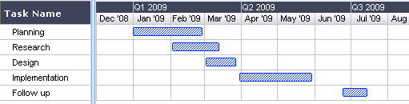

**References:**

1. <http://www.gantt.com/>

RMMM plan

The risk components are defined in the following manner:

* **Performance** risk—the degree of uncertainty that the product will meet its requirements and be fit for its intended use.
* **Cost** risk—the degree of uncertainty that the project budget will be maintained.
* **Support** risk—the degree of uncertainty that the resultant software will be easy to correct, adapt, and enhance.
* **Schedule** risk—the degree of uncertainty that the project schedule will be maintained and that the product will be delivered on time.

The impact of each risk driver on the risk component is divided into one of four impact categories—**negligible, marginal, critical, or catastrophic.**

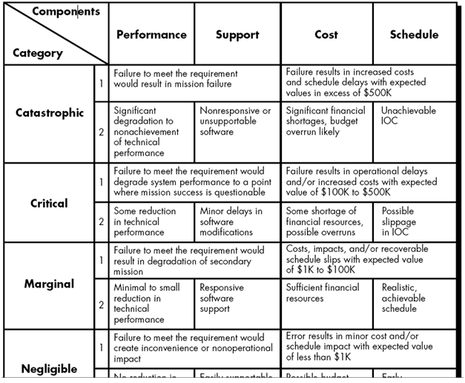

Imapct assessment

1. Develop a risk table

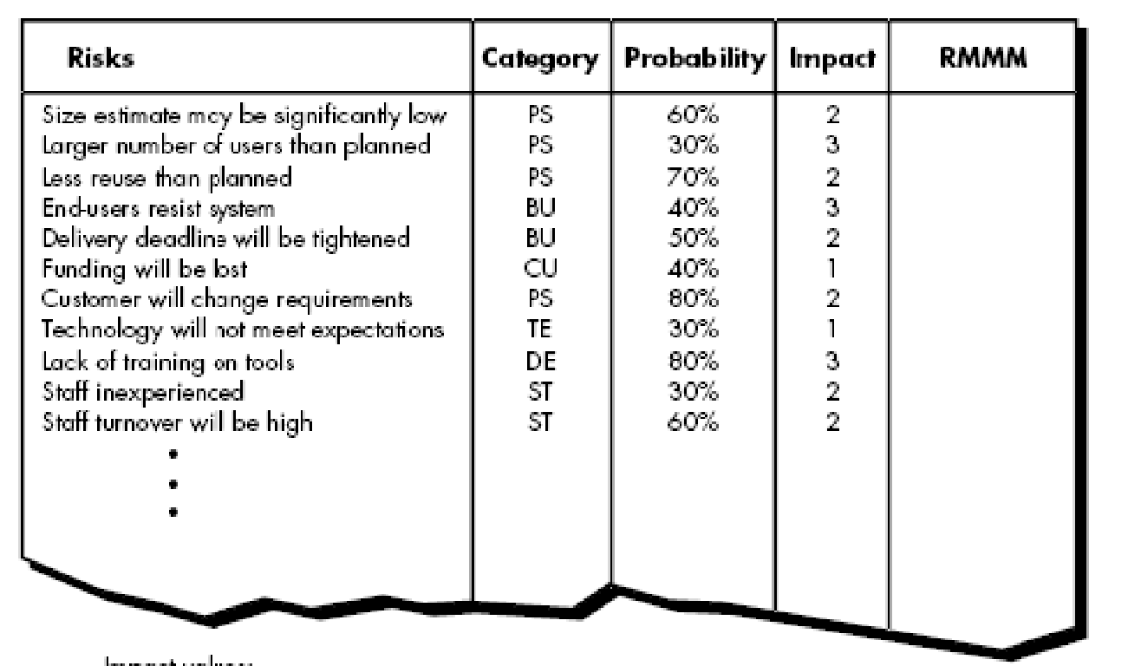

For risks with high impact adn high probability create a RMMM plan

**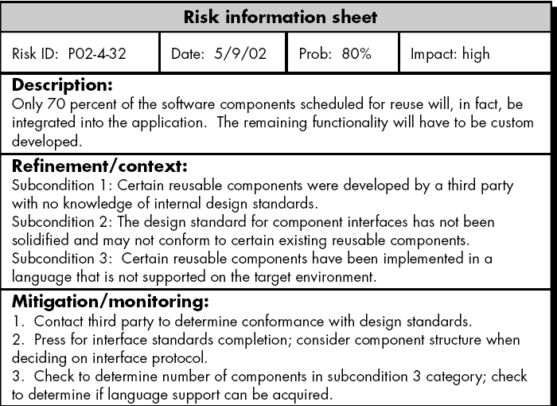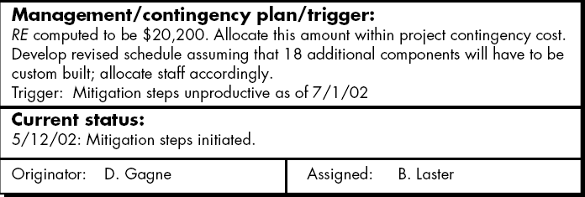**

**Expt 8**

**AIM:** Change specification and use any SCM Tool to make different versions

**Theory :**

Software configuration management: The traditional software configuration management (SCM) process is looked upon by practitioners as the best solution to handling changes in software projects. It identifies the functional and physical attributes of software at various points in time, and performs systematic control of changes to the identified attributes for the purpose of maintaining software integrity and traceability throughout the software development life cycle.

The SCM process further defines the need to trace changes, and the ability to verify that the final delivered software has all of the planned enhancements that are supposed to be included in the release. It identifies four procedures that must be defined for each software project to ensure that a sound SCM process is implemented. They are:

1. Configuration identification
2. Configuration control
3. Configuration status accounting
4. Configuration audits

These terms and definitions change from standard to standard, but are essentially the same.

* Configuration identification is the process of identifying the attributes that define every aspect of a configuration item. A configuration item is a product (hardware and/or software) that has an end-user purpose. These attributes are recorded in configuration documentation and baselined. [Baselining](http://en.wikipedia.org/wiki/Baseline_%28configuration_management%29) an attribute forces formal configuration change control processes to be effected in the event that these attributes are changed.
* Configuration change control is a set of processes and approval stages required to change a configuration item's attributes and to re-baseline them.
* Configuration status accounting is the ability to record and report on the configuration baselines associated with each configuration item at any moment of time.
* Configuration audits are broken into functional and [physical configuration audits](http://en.wikipedia.org/wiki/Physical_configuration_audit). They occur either at delivery or at the moment of effecting the change. A functional configuration audit ensures that functional and performance attributes of a configuration item are achieved, while a physical configuration audit ensures that a configuration item is installed in accordance with the requirements of its detailed design documentation.

 GitHub offers all of the [distributed revision control](https://en.wikipedia.org/wiki/Distributed_revision_control) and [source code management](https://en.wikipedia.org/wiki/Source_code_management) (SCM) functionality of [Git](https://en.wikipedia.org/wiki/Git_(software)) as well as adding its own features. Unlike Git, which is strictly a [command-line](https://en.wikipedia.org/wiki/Command-line) tool, GitHub provides a [Web-based graphical interface](https://en.wikipedia.org/wiki/Web_application) and desktop as well as mobile integration. It also provides [access control](https://en.wikipedia.org/wiki/Access_control) and several collaboration features such as [bug tracking](https://en.wikipedia.org/wiki/Bug_tracking_system), [feature requests](https://en.wikipedia.org/wiki/Software_feature), [task management](https://en.wikipedia.org/wiki/Task_management) for every project.

For Faculty Usehttps://docs.google.com/drawings/u/0/d/sekwtG188UjWa3SoGuP7P4w/image?w=814&h=3&rev=1&ac=1&parent=1ok0uxvmAUDJURzD1ZTcvRNp-oe_CBKJ9sZtSYbqh9Dg

| **Correction Parameters** | **Formative Assessment [40%]** | **Timely completion of Practical [ 40%]** | **Attendance / Learning Attitude [20%]** |  |
| --- | --- | --- | --- | --- |
| **Marks Obtained** |  |  |  |

**Experiment 9:** **Design test cases and generate test scripts in Selenium**

**Learning Objective:** Students will able to create unit test cases

**Tools:**  Selenium record and playback

**Theory:**

Software testing is an investigation conducted to provide stakeholders with information about the quality of the product or service under test. Software testing also provides an objective, independent view of the software to allow the business to appreciate and understand the risks of software implementation.

Write a program to calculate the square of a number in the range 1-100

#include <stdio.h>

int main()

{

int n, res;

printf("Enter a number: ");

scanf("%d", &n);

if (n >= 1 && n <= 100)

{

res = n \* n;

printf("\n Square of %d is %d\n", n, res);

}

else if (n<= 0 || n > 100)

printf("Beyond the range");

return 0;

}

| Sr no | Input | Output |
| --- | --- | --- |
| 1 | -2 | Beyond the range |
| 2 | 0 | Beyond the range |
| 3 | 1 | Square of 1 is 1 |
| 4 | 100 | Square of 100 is 10000 |
| 5 | 101 | Beyond the range |
| 6 | 4 | Square of 4 is 16 |
| 7 | 62 | Square of 62 is 3844 |

Test Cases

Test case 1 : {I1 ,O1}

Test case 2 : {I2 ,O2}

Test case 3 : {I3, O3}

Test case 4 : {I4, O4}

Test case 5 : {I5, O5}

Test case 6 : {I6, O6}

Test case 7 : {I7, O7}

**Black-box testing**

Knowing the specified function that a product has been designed to perform, test to see if that function is fully operational and error free. Includes tests that are conducted at the software interface. Not concerned with internal logical structure of the software

It uncovers

* Incorrect or missing functions
* Interface errors
* Errors in data structures or external data base access
* Behavior or performance errors
* Initialization and termination errors

**Learning Outcomes:** Students should have the ability to

**LO1:** Students will be able to understand Software Testing Concepts and the various Software standards.

**LO2**: to test a software with the help ofJunit

**LO3**: create test cases

**LO4**: To understand different tools for testing

**Outcomes:** Upon completion of the course students will be able to write test cases for the project.

**Conclusion:**

We have implemented white box testing and understood the use of white box testing in real life projects for test cases.

**Viva Questions:**

1. **What is difference between white box and black box testing?**
2. **What are Software Testing Concepts?**

For Faculty Use

| **Correction Parameters** | **Formative Assessment [40%]** | **Timely completion of Practical [ 40%]** | **Attendance / Learning Attitude [20%]** |  |
| --- | --- | --- | --- | --- |
| **Marks Obtained** |  |  |  |